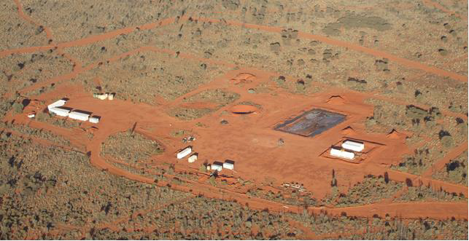

**Surprise Field Development Project**

**Field Environment Management Plan Summary**

Central Petroleum Ltd – Surprise Field Development Project

Field Environment Management Plan Summary

**TABLE OF CONTENTS**

**1.**

**2.**

**3.**

**4.**

**PROPONENT ......................................................................................................................... 3**

**PROJECT OVERVIEW ............................................................................................................. 3**

**LOCATION ............................................................................................................................ 4**

**DESCRIPTION OF PROJECT..................................................................................................... 6**

4.1.

Stage 1: Surprise West Production ......................................................................................... 6

4.1.1.

4.1.2.

Conduct workover of Surprise 1 RE/HST 1 to install hydraulic pump............................. 6

Install production facility, including: ............................................................................... 6

4.2.

Stage 2: Surprise East Exploration .......................................................................................... 7

4.2.1.

Drill an appraisal well in the Surprise East compartment (Surprise East 1).................... 7

4.3.

4.4.

Stage 3: Additional Recovery and Optimisation ..................................................................... 7

Supporting Infrastructure and Services .................................................................................. 8

**5.**

**6.**

**7.**

**DESCRIPTION OF ENVIRONMENT .......................................................................................... 9**

**ENVIRONMENTAL MANAGEMENT MEASURES ..................................................................... 10**

**CONSULTATION .................................................................................................................. 13**

**TABLE OF FIGURES**

Figure 3.1: General location of proposed development for the Surprise Field ...................................... 5

**LIST OF TABLES**

Table 6.1: Risks associated with establishing sites and increasing use of the project area ................. 10

Table 6.2: Risks associated with production, storage and transport of hazardous materials .............. 11

**PREFACE**

As the Surprise Field Development Project Field Environment Management Plan was first submitted to the Department of Mines and Energy in September 2013 (6 months ago), significant progress in the plans for development have occurred and more information on the proposed activities is now available. CTP are currently in the process of revising the FEMP and will submit the revised document to the DME for approval. In order to provide an up-to-date and accurate overview of the project, this summary contains some of the additional information that will be included in the revised FEMP.

Low Ecological Services P/L

March 2014

Page ii

Central Petroleum Ltd – Surprise Field Development Project

Field Environment Management Plan Summary

**1. PROPONENT**

Central Petroleum Limited (CTP) was formed in 1998 and is an Australian Securities Exchange (ASX)

listed junior exploration and production company. CTP operate the largest holding of prospective onshore acreage in Australia totalling over 270,000 km2, c.70 million acres, all of which is located in Central Australia. This acreage includes permits already awarded and acreage under application with

250,000 km2 under the Petroleum Acts and 20,000 km2 under the Mining Acts; mainly in the

Northern Territory with smaller holdings in Western Australia, South Australia and Queensland.

CTP’s acreage includes the majority of the Pedirka Basin within the Northern Territory and South Australia, the majority of the Amadeus Basin in the Northern Territory, all of the known Lander Trough in the Northern Territory and approximately 25,000 km2 in the Southern Georgina Basin. This acreage has been assembled since 1998 when the company was first formed as Merlin Synergy NL.

CTP has recently executed a binding agreement to acquire Palm Valley and Dingo gas field assets in

Central Australia from Magellan Petroleum.

**2. PROJECT OVERVIEW**

CTP propose a three stage works program to develop the Surprise Field:

**Stage 1: Surprise West Production**

The following activities are required to bring Surprise 1 RE/HST 1 well into production:

•

•

•

Conduct workover of Surprise 1 RE/HST 1 to install hydraulic pump;

Conduct a second EPT on Surprise 1 RE/HST 1 with pump in place; Install production facility, including:

o Infield treatment facilities;

o Storage facilities; and

o Loading facilities; and

Commence production of crude oil from Surprise 1 RE/HST 1.

•

**Stage 2: Surprise East Exploration**

Drill an appraisal well in the Surprise East compartment (Surprise East 1).

If successful, a workover, EPT and flowline to the production facility may be required.

Additional appraisal and production wells may be considered at some stage during the production life of the field but are currently beyond the scope of development.

**Stage 3: Additional Recovery and Optimisation**

Additional recovery and optimisation techniques may be considered at some stage during the production life of the field but are currently beyond the scope of development.

Low Ecological Services P/L

March 2014

Page 3

Central Petroleum Ltd – Surprise Field Development Project

Field Environment Management Plan Summary

**3. LOCATION**

The Surprise Field is located in the Amadeus Basin, approximately 500 km west of Alice Springs in the

Northern Territory. All proposed development for the field is contained within Northern Territory Exploration Permit 115 (granted 1984) and the recently granted Northern Territory Production Licence 6 (granted February 2014).

Access to the field from Alice Springs is via sealed and unsealed public roads and existing access roads constructed by CTP during exploration of the area.

The nearest population is the community of Kintore, 80 km to the north-west. The area is entirely within the Haasts Bluff Aboriginal Land Trust.

Low Ecological Services P/L

March 2014

Page 4

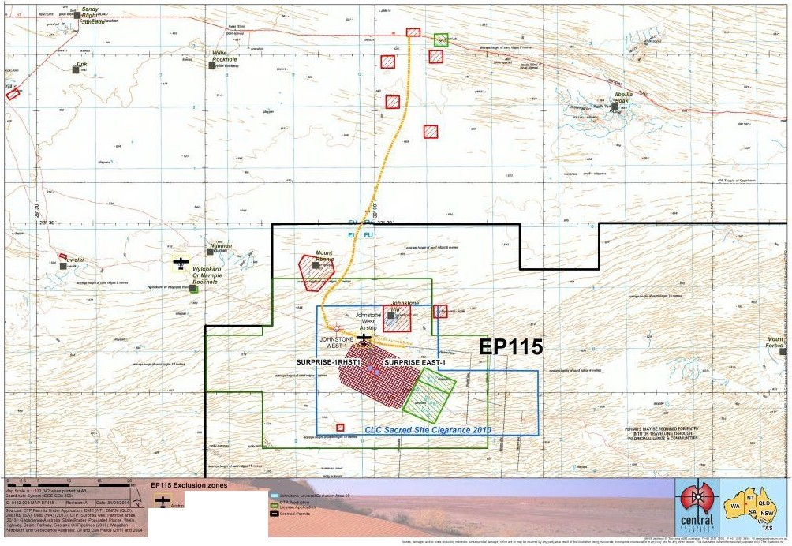

Central Petroleum l.1d- Surprise FieId Development Project

Field Environm ent Management Plan Summary

-xu....•Jo.<t>ooo..N<o••

_,._lO..,.e._....t....

c:u-r••.

......."'.._" §=:-"::·,::......)).0

::.!.::::; ..;o.:;::; .-.::..""'..::w.-::...--··--..------ ....--------"---·---·-..--

Figure 3.1: General location of proposed dewlopment for the Surprise Field (Surprise 1RE/HST1is shown on the map as Surprise 1RHST1)

March 2014

Low Ecological Services P/L

Page 5

Central Petroleum Ltd – Surprise Field Development Project

Field Environment Management Plan Summary

**4. DESCRIPTION OF PROJECT**

**4.1. STAGE 1: SURPRISE WEST PRODUCTION**

**4.1.1. Conduct workover of Surprise 1 RE/HST 1 to install hydraulic pump**

The Extended Production Test conducted by CTP in 2012 indicated the well requires artificial lift to

maintain flow.

An environmental plan for a workover to install the pump was submitted to and approved by the

DME under the Exploration Permit EP115. The workover is currently in progress.

**4.1.2. Install production facility, including:**

CTP propose to construct a new production treatment, storage and load out facility, if results justify,

for the Surprise Field.

The key objectives of the facility will be to:

•

•

Provide for the production from Surprise 1 RE/HST 1 in its initial configuration;

Provide basic separation facilities to condition the produced crude oil for transport to Port

Bonython, South Australia for further processing;

Provide sufficient storage facilities to enable efficient road transportation of the produced crude oil as well as providing a suitable buffer in the event of weather related access constraints and trucking issues, so as to avoid interruption to production; and

Provide metering and truck load out facilities.

•

•

The FEMP state that a maximum area of approximately 400 m x 400 m (16ha) will be required for

the construction of the production facility. Existing cleared/disturbed areas will be used to the greatest extent practicable to reduce the amount of vegetation clearance required. Potential sites for the location of the facility were proposed in the FEMP and those locations surveyed by LES for the presence of threatened flora and fauna and sensitive environments.

Since the submission of the FEMP, it has been determined the production facility will be constructed at the Surprise 1 RE/HST 1 well site. Approximately 8500 square metres (> 1 ha) of clearing will now be required to accommodate the facility at the site. In addition to minimising clearing required for the facility, locating it at the well site also eliminates clearing for the flowline from Surprise 1 RE/HST

1 well to the production facility. The flowline will now be constructed as an above ground steel pipeline approximately 50 m in length and will be located within the existing cleared site.

The production facility will be designed and constructed in accordance with relevant legislation as well as Australian standards and industry codes of practice referred to under the legislation.

Low Ecological Services P/L

March 2014

Page 6

Central Petroleum Ltd – Surprise Field Development Project

Field Environment Management Plan Summary

**4.2. STAGE 2: SURPRISE EAST EXPLORATION**

**4.2.1. Drill an appraisal well in the Surprise East compartment (Surprise East 1)**

For the drilling operation, an FEMP bridging document will be developed and submitted to the DME

for approval. The bridging document will detail the proposed drilling operations, identify and assess the environmental risks and outline management measures CTP will employ to minimise the impacts of the drilling operation on the surrounding environment. Given the close proximity to Surprise 1

RE/HST 1 well site, the risks and management measures will be similar to those identified in the

*Surprise-1 Sidetrack 1 (S1-ST1) Environmental Management Plan*, with site specific considerations incorporated following environmental assessment.

The coordinates of the current proposed location for the Surprise East 1 well are S 23°43”18.5’, E

130°00”13.0’.

In addition, sites proposed as well locations will be assessed by an independent consultant for the presence of threatened species. Sites may or may not require an on-ground survey depending on the site location in relation to previous on-ground surveys conducted.

The same process will be used for any other additional appraisal or production wells.

**4.3. STAGE 3: ADDITIONAL RECOVERY AND OPTIMISATION**

As mentioned additional recovery and optimisation techniques may be considered at some stage

during the production life of the field but are currently beyond the scope of development.

Planning for stage 3 of operations relies on data collected during stage 1 and 2 of the development of the production field. Based on current understanding, this may include:

•

•

•

A possible pressure support/water injection scheme in Surprise West;

Drilling additional injection wells as part of the injection/pressure support scheme;

Possible pressure support scheme for the Surprise East field, should its reservoir characteristics be similar to Surprise West; and

Exploration well targeting the lower deep gas prospects.

•

Should development of the Surprise production field progress to stage 3, an additional, stage specific

Environmental Management Plan will be developed, prior to any of the above operations commencing.

It is important to note that CTP consider it unlikely that hydraulic fracturing in the Lower Stairway

Sandstone (the reservoir horizon that hosts the commercial oil discovery) would prove beneficial.

There is a potential that hydraulic fracturing may be required for the lower deep gas prospects but this type of exploration is beyond the scope of the current project. If, and when, additional recovery and optimisation is proposed for the field, CTP will obtain the required government approvals including undertaking the required risk assessment and stakeholder consultation.

Low Ecological Services P/L

March 2014

Page 7

Central Petroleum Ltd – Surprise Field Development Project

Field Environment Management Plan Summary

**4.4. SUPPORTING INFRASTRUCTURE AND SERVICES**

Supporting infrastructure and services including camp, access roads, water, domestic waste and

power will remain the same as was used previously for the Surprise 1 RE/HST 1 Extended Production

Test.

The main sources of waste from production are produced water and gas.

Produced water will be disposed of in a lined evaporation pond, most likely the same one constructed for the 2012 EPT. Pond design, in combination with monitoring will ensure the pond is fit for purpose to prevent produced water escaping to the surrounding environment. Water content produced during the previous EPT was approximately 8% of the oil produced. At a production rate of

400 barrels per day, approximately 32 barrels of produced water would be discharged to the evaporation pond.

Results of the 2012 EPT, found a very low gas to oil ratio (GOR). Produced gas will be piped and vented; most likely at the top of the highest tank. The outlet pipe will be fitted with a flame arrester to mitigate the risk of combustion in the system in the unlikely event of ignition of the vented gas. Due to the low levels of anticipated gas emissions, flaring will not be required at this stage. Produced gas is also expected to decrease as reservoir pressure drops over the production life of the well. If at any stage production of the well is likely to significantly exceed the projected quantity of produced gas, management of emissions will be revised.

Chemicals and wastes from drilling operations will be managed in a similar manner as the Surprise 1

RE/HST 1 drilling operations. These

submitted to the DME for approval.

will

be

addressed

in

the

FEMP

bridging

document

to

be

Low Ecological Services P/L

March 2014

Page 8

Central Petroleum Ltd – Surprise Field Development Project

Field Environment Management Plan Summary

**5. DESCRIPTION OF ENVIRONMENT**

The PL area is in an arid climate and experiences highly variable rainfall with an average annual

rainfall of 255 mm.

The majority of the PL area is located in extensive sand plains and dune fields, consistent with the

Simpson land system that dominates much of Central Australia.

Key features of the surrounding area include the gypsum Johnstone Hill and footslopes as well as a system of claypans to the east of the existing Surprise 1 RE/HST 1 well site.

Across the PL area, *Spinifex* spp. hummock grassland dominates the understorey with mid and upper storeys varying in composition of *Acacia* spp.*, Corymbia* spp.*, Eucalyptus* spp. and/or Desert Oak (*Allocasuarina decaisneana*).

There are no major watercourses in the area, however scattered claypans are considered to be of potential importance for cultural/heritage reasons.

The results of flora and fauna surveys (desktop and field) of the area indicate that although potential habitat exists for a number of threatened species, due to the level of development proposed and the development being located in an expansive land system, significant impacts on the populations of potentially occurring threatened species is considered unlikely. These reports recommend that CTP should still consider and minimise local impacts on threatened species.

Introduced species common to central Australia that have been recorded in the area include Buffel

Grass, Camels, Rabbits, Cats and Foxes.

Low Ecological Services P/L

March 2014

Page 9

Central Petroleum Ltd – Surprise Field Development Project

Field Environment Management Plan Summary

**6. ENVIRONMENTAL MANAGEMENT MEASURES**

The Surprise Field Development plan will be managed within the broader framework of CTP’s Health,

Safety and Environment Integrated Management System (CTP HSE IMS).

A risk assessment is included in the FEMP. The risk assessment identifies all potential hazards, assesses the likelihood of those hazards to impact the environment and provides management measures for managing the risk to as low as reasonably practicable.

Although the risk assessment did not identify any high risks once management measures were taken into consideration, the most significant risks associated with the project are discussed below.

**Table 6.1: Risks associated with establishing sites and increasing use of the project area**

Low Ecological Services P/L

March 2014

Page 10

**Vegetation Clearing**

**Risk Element**

**Details**

**Consequence**

• Loss of habitat

• Harm to threatened species

• Disturbance to topsoil and erosion

• Weed introduction / spread

• Damage to archaeological / heritage sites

• Disruption to surface hydrology

• Place access tracks on previously cleared seismic lines

• Conduct flora/fauna surveys using best practice guidelines along proposed road corridors

• Divert around large trees and dense vegetation patches

• Environmental induction for all CTP personnel, contractors and visitors to site.

Induction to include the identification of threatened species possibly occurring

• Avoid the formation of windrows

• Construct diversion banks and whoa boys so as to maintain natural surface hydrology

• Vehicle and machinery wash-down prior to leaving Alice Springs or entering an area uncontaminated by weeds

• Production facility will utilise existing cleared areas if possible

• If above not possible, facility will be constructed at sites already subjected to detailed flora and fauna surveys

• Where neither of the above scenarios is possible, additional flora and fauna surveys will be carried out prior to any vegetation clearance taking place

• NT land clearing guidelines will be followed

• Pipelines will be constructed along existing cleared seismic lines

• Where above not possible, detailed flora and fauna surveys will be carried out within pipeline corridors

**Management Measures**

**Movement of Machinery / Vehicles**

**Risk Element**

**Details**

**Consequence**

• Dust generation

• Soil compaction

• Soil erosion

• Damage to vegetation / habitat loss

• Injury or death to native fauna

• Damage to archaeological / heritage sites

• Increased public access to remote areas

• Weed introduction / spread

• Ignition of wildfire on road corridor

**Management Measures**

• Off road driving prohibited

• Maximum speed of 60 km/h on main access and haul roads

• Rehabilitate dis-used access roads by ripping

Central Petroleum Ltd – Surprise Field Development Project

Field Environment Management Plan Summary

**Table 6.2: Risks associated with production, storage and transport of hazardous materials**

Low Ecological Services P/L

March 2014

Page 11

**Fuel Spills and Leaks**

**Risk Element**

**Details**

**Consequence**

• Contamination of soil

• Contamination of watercourses / water table

• Access to contaminated soil / water by wildlife

**Management Measures**

• Do not situate fuel storage areas in sensitive environments, including within

50m of a watercourse, spring, well or bore

• Fuel storage and transfer areas to be appropriately lined with PVC and bunded with enough capacity to capture 110% volume critical failure of all storage tanks in the bunded area

• Fuel storage and handling procedures in accordance with relevant standards, including AS 1940 and the Australian Dangerous Goods Code

• Spills of more than 175 L reported to DME

• Ensure that bunded areas are emptied of water following rainfall. If contaminated, water should be properly disposed of to an authorised waste facility

• Water pump on site to remove any rain water from bunded areas

• Refuelling of vehicles / machinery to occur only within bunded area

• Spill kits on site at all times

**Loss of Containment of Oil (pipeline rupture or leaks from plant equipment)**

**Risk Element**

**Details**

**Consequence**

• Contamination of soil

• Contamination of watercourses / water table

• Access to contaminated soil / water by wildlife

**Management Measures**

• Fuel storage and transfer areas to be appropriately lined with PVC and bunded with enough capacity to capture 130% volume critical failure of all storage tanks in the bunded area

• Three lined and bunded areas to be established; one at separator tanks, one around storage tanks and one at the loading area

• Ensure that bunded areas are emptied of water following rainfall. If contaminated, water should be properly disposed of to an authorised waste facility

• Vehicle and machinery wash-down prior to leaving Alice Springs or entering an area uncontaminated by weeds

• Environmental induction for all CTP personnel, contractors and visitors to site.

• Report and record injury or death of native fauna

**Earthworks**

**Risk Element**

**Details**

**Consequence**

• Disturbance to top soil and erosion

• Disruption to surface hydrology

• Habitat loss

• Harm to threatened species

**Management Measures**

• Avoid constructing access roads on sand dunes where possible.

• Place access tracks on previously cleared seismic lines

• Stockpile topsoil for use at rehabilitation stage

• Rehabilitate access roads at site closure

• Conduct flora/fauna surveys using best practice guidelines in proposed areas of disturbance

• Diversion, pond banks and whoa-boys will be constructed where necessary to reduce water flow

• Formation of windrows will be discouraged

• Travel speed will be limited to 60 km/h

• Environmental induction for all CTP personnel, contractors and visitors to site

Central Petroleum Ltd – Surprise Field Development Project

Field Environment Management Plan Summary

Low Ecological Services P/L

March 2014

Page 12

• Water pump on site to remove any rain water from bunded areas

• Report crude oil spills to DME

• All flowlines pressure tested with water prior to start up

• Oil spill contingency plan in place

**Well Control Event**

**Risk Element**

**Details**

**Consequence**

• Contamination of soil

• Contamination of watercourse / watertable

• Access to contaminants by fauna

• Uncontrolled fire

• Atmospheric pollution

**Management Measures**

• Blow out preventer used during drilling operations from when 13 3/8” casing is

set through to when the well is plugged and abandoned or well head installed

• Oil spill contingency plan in place

• Emergency response plan in place and emergency response drills conducted regularly

**Fuel spills and leaks associated with refuelling of vehicles and machinery**

**Risk Element**

**Details**

**Consequence**

• Contamination of soil

• Contamination of watercourses / water table

• Access to contaminated soil / water by wildlife

**Management Measures**

• Fuel storage and transfer areas to be appropriately lined with PVC and bunded with enough capacity to capture 110% volume critical failure of all storage tanks in the bunded area

• Refuelling of vehicles / machinery to occur only within bunded area

• If above not possible, drip trays to be used whilst refuelling

• Spill kits on site at all times

**Explosion or fire at the Facility / Plant**

**Risk Element**

**Details**

**Consequence**

• Contamination of soil

• Contamination of watercourse / water table

• Danger to health and safety of employees and contractors

• Atmospheric pollution

**Management Measures**

• All pipelines and facilities constructed to appropriate standards

• Safety, testing, maintenance and inspection procedures are implemented

• Appropriate inductions and training completed by all staff, contractors and visitors

• Safe work permits to be obtained to ensure that only individuals trained appropriately can conduct work

• Petrol vehicles to be excluded from well/pipeline sites

• Immediate clean-up and remediation to minimise contamination

• All personnel aware of emergency procedures

**Storage and Disposal of Produced Formation Water**

**Risk Element**

**Details**

**Consequence**

• Contamination of soil, surface water and / or ground water

• Access by fauna to produced water

**Management Measures**

• Produced water stored in PVC lined evaporation ponds

• Evaporation pond will be fenced to prevent animals coming into contact with produced water

• Once water has evaporated, PVC lining will be removed with evaporites and disposed of by an approved waste contractor to a licenced waste management facility

Central Petroleum Ltd – Surprise Field Development Project

Field Environment Management Plan Summary

**7. CONSULTATION**

As the Surprise Field is located on Aboriginal land, CTP has extensively negotiated and formed

agreements with Traditional Owners and the CLC for both exploration and, more recently, production and the proposed development of the field.

Being the first production licence to be granted for decades in the NT, CTP have also liaised directly with the NT government to determine the level of information required for the relevant departments to assess the project.

CTP will make itself available for consultation with relevant government authorities, interested persons or organisations as required and will ensure CTP contact details are made publicly available. Any complaints will be recorded and managed in accordance with CTP’s Complaints Management Strategy and CTP’s Health, Safety and Environment (HSE) reporting system.

**CTP Contact Details:**

Mike Herrington

**Chief Operating Officer**

**07 3181 3808**

Cameron Crawford

**Operations Manager**

**07 3181 3836**

Bob Liddle

**Land Manager**

**03 9870 6055**

Low Ecological Services P/L

March 2014

Page 13