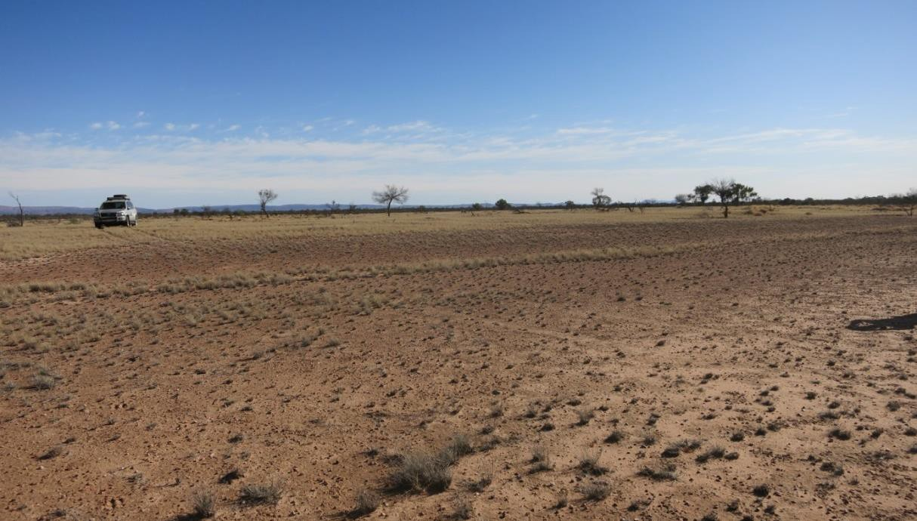

**DINGO GAS FIELD DEVELOPMENT PROJECT**

**FIELD ENVIRONMENTAL MANAGEMENT PLAN SUMMARY**

**June 2014**



**TABLE OF CONTENTS**

**1. PROPONENT ......................................................................................................................... 3**

**2. LOCATION ............................................................................................................................ 4**

**3. PROJECT OVERVIEW ............................................................................................................. 7**

**4. DESCRIPTION OF OPERATIONS .............................................................................................. 8**

4.1. Wellhead Facilities .................................................................................................................. 8

4.2. Field Gathering System ........................................................................................................... 8

4.2.1. Dingo #2 and Dingo #3 Wellhead Flowlines.................................................................... 8

4.2.2. Field Manifold Site .......................................................................................................... 8

4.3. Supporting Infrastructure and Services .................................................................................. 8

**5. DESCRIPTION OF ENVIRONMENT ........................................................................................ 10**

**6. ENVIRONMENTAL MANAGEMENT MEASURES ..................................................................... 14**

**7. CONSULTATION .................................................................................................................. 17**

**8. REFERENCES ....................................................................................................................... 18**

**TABLE OF FIGURES**

Figure 2.1: General Location of Production Licence 7 and proposed field development ...................... 5

Figure 2.2: General Location of the Dingo Gas Field Development project over Google Earth satellite imagery ................................................................................................................................................... 6

Figure 5.1: PL7 in relation to surface hydrology ................................................................................... 12

Figure 5.2: Vegetation Classes (Wilson et al., 1991) and records of *Eremophila prostrata* from the

Atlas of Living Australia......................................................................................................................... 13

**LIST OF TABLES**

Table 4.1: Wellhead flowlines size, length and materials ....................................................................... 8

**FRONTISPIECE**

Undulating limestone country along the Dingo Gas Pipeline Alignment with West MacDonnell Ranges in background (40 km away).

Low Ecological Services P/L June 2014 Page ii

**1. PROPONENT**

Central Petroleum Limited has recently acquired the Palm Valley and Dingo Gas Field assets in Central Australia from Magellan Petroleum (NT) Pty. Ltd. a wholly-owned subsidiary of the Australian holding company Magellan Petroleum Australia Pty Ltd. The proponent of the Dingo Gas Field Development Project will henceforth be the wholly owned subsidiary of Central Petroleum Limited, Central Petroleum (NT) Pty. Ltd.

Central Petroleum Limited was formed in 1998 and is an Australian Securities Exchange (ASX) listed junior exploration and production company. Central Petroleum Limited operate the largest holding of prospective onshore acreage in Australia totalling over 270,000 km2, c.70 million acres, all of which is located in Central Australia. This acreage includes permits already awarded and acreage under application with 250,000 km2 under the Petroleum Acts and 20,000 km2 under the Mining Acts; mainly in the Northern Territory with smaller holdings in Western Australia, South Australia

and Queensland.

|  |  |
| --- | --- |
| **Company Name** | Central Petroleum (NT) Pty. Ltd. |
| **ACN/ABN** | ACN: 009 718183 / ABN: 95 009 718183 |
| **Street Address** | 56-58 Jephson Street, TOOWONG QLD 4066 |
| **Postal Address** | PO Box 1571, TOOWONG DC QLD 4066 |
| **Telephone** | +61 (0)7 3181 3800 |
| **Facsimile** | +61 (0)7 3181 3855 |
| **Email** | [info@centralpetroleum.com.au](mailto:info@centralpetroleum.com.au) |
| **Website** | [www.centralpetroleum.com.au](http://www.centralpetroleum.com.au/) |

Central Petroleum Limited’s acreage includes the majority of the Pedirka Basin within the Northern Territory and South Australia, the majority of the Amadeus Basin in the Northern Territory, all of the known Lander Trough in the Northern Territory and approximately 25,000 km2 in the Southern Georgina Basin. This acreage has been assembled since 1998 when the company was first formed as Merlin Synergy NL. Central Petroleum Limited is currently developing the Surprise Field in the Amadeus Basin for crude oil production under the recently granted Production Licence 6.

**2. LOCATION**

The Dingo Gas Field is located in the northeast of the Amadeus Basin, Northern Territory, approximately 50 km south of Alice Springs on Orange Creek Station. The production licence area, PL7 granted in May 2014 covers six graticular blocks that previously made up the Retention Lease, RL2.

The production licence area is accessed from Alice Springs via the unsealed Maryvale Road South and turning west along Orange Creek Pastoral Lease road. Parallel to the Adelaide-Darwin Railway line, a railway access road goes directly to the production licence area. Access to the well sites is east from the railway access road along a station track. This road is subject to permitted use only and permits providing access for the project is currently in place.

A map showing the general location of PL7 is shown in Figure 2.1.

As shown in Figure 2.2, the proposed pipeline route runs approximately 37.5 km north to connect the Dingo Gas Field to the proposed city gate gas treatment facility at Brewer Industrial Estate, located on Brewer Road, accessed via the Stuart Highway, approximately 20 km south of Alice Springs.

Central Petroleum (NT) Pty. Ltd.- Dingo Gas Field Development Project

Field Environment Management Plan Summary

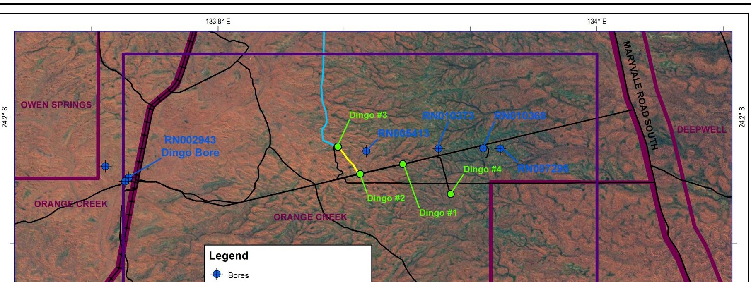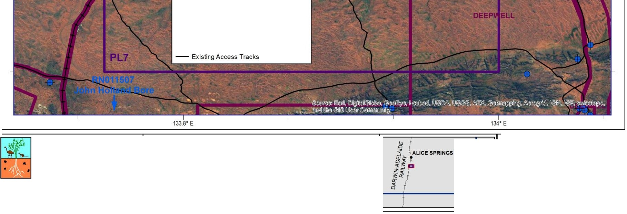

**E:]**Production Licence Application Area

0 Existing Wells

-+- Adelaide-Darwin Railway

-- Proposed Dingo Pipeline

Proposed Dingo #2 Wellhead Flowline

For further information,please contact: PROJECTION: DATA SOURCE: Low Ecological Services P/L LaVLon hddd.ddddd' Background:

Phone: {08) 89555 222 HORIZONTAL DATUM: ESRI,DigitaiGiobe, Geoeye, i-cubed,USDA, [www.lowecol.com.au](http://www.lowecol.com.au/) Geodetic Datum of Australia 1994 USGS, AEX,Getmapping, Aerogrid,IGN, IGP, [lowecol@lowecol.com.au](mailto:lowecol@lowecol.com.au) swisstopo, and the GIS User Community

o w E co Io g ic a I Services PI L --------- : :_= .;:N- ----_:_-----'---j

NT QLD

**Dingo Gas Field Development project**

**General Location**

I. o 1.25 2.5

5

Kilometers

***1'\.*** Scale: 1: 150,000

SA **Production Licence 7**

C copyrht Map compiled Feb 2014 by RW.Eedd June 2014 by RW.Ref C:IROZ\GIS\Maps\MageltarlfEMP\Location_PLA\location_PLA

**Figure 2_1:General location of Production Licence 7 and proposed field development**

low Ecological Services P/l June 2014 PageS

**Production Licence 7**

**Figure 2.2: General Location of the Dingo Gas Field Development project over Google Earth satellite imagery**

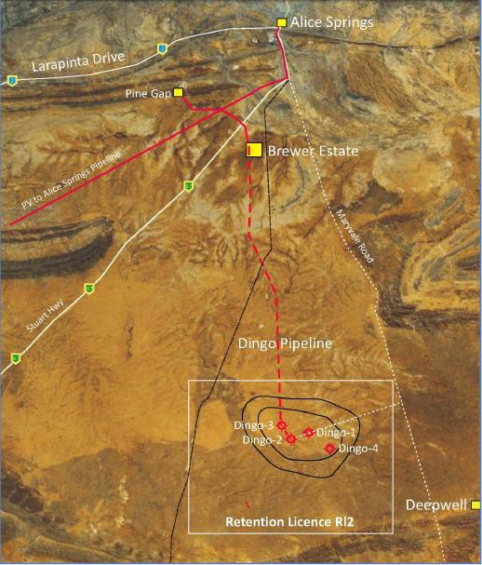

Low Ecological Services P/L June 2014 Page 6

**3. PROJECT OVERVIEW**

Central Petroleum (NT) Pty Ltd intend to develop the Dingo Gas Field to supply over half of Alice Springs current energy demand for up to 20 years depending on sales demand. This supply will replace the dwindling Palm Valley gas field supply. The main customer will be Power and Water Corporation.

There are currently four wells in the Dingo Gas Field (Dingo #1, Dingo #2, Dingo #3 and Dingo #4) all of which were completed between 1984 and 1991. The current status of the wells is as follows:

• Dingo #1: Not capable of production due to collapsed casing from salt diapir movement

• Dingo #2: Cased and suspended

• Dingo #3: Cased and suspended

• Dingo #4: Plugged and abandoned due to saline water being encountered in the reservoir

The retention licence (RL2) which covers the gas field and surrounds has been replaced with a Production

License PL7 granted in May 2014.

Gas will be initially produced from the currently cased and suspended wells (Dingo #2 and Dingo #3), gathered through a field manifold site and transported through a proposed 45 km pipeline to Brewer Industrial Estate. The raw gas will be treated to pipeline sales gas quality in a proposed city gate gas treatment facility at Brewer Industrial Estate. A proposed sales gas pipeline will transport the sales gas to a connection point on the ENVESTRA-owned pipeline that supplies gas to the Owen Springs Power Station at Brewer Industrial Estate.

The Dingo Gas Field Development project has been divided into three sub-projects:

• Brewer Estate City Gate Gas Treatment Facility

• Dingo Pipeline

• Wellhead Facilities and Field Gathering System

The Brewer Estate City Gate Gas Treatment Facility and Dingo Pipeline will be managed and assessed under the *Energy Pipelines Act*.

The Wellhead Facilities and Field Gathering System to be located in the production licence area will be managed and assessed under the *Petroleum Act*. This document is a summary of the Field Environmental Management Plan (FEMP) submitted as part of the application for a production licence under the *Petroleum Act* and therefore does not provide detail on the proposed Dingo Pipeline or Brewer Estate City Gate Gas Treatment Facility.

**4. DESCRIPTION OF OPERATIONS**

**4.1. WELLHEAD FACILITIES**

Minimal work is required at both the Dingo #2 and Dingo #3 well sites in order to bring the wells into production. Work required at each well site involves installing a remote terminal unit, metering skid and two metre chain wire fencing around the wellhead and facilities to prevent third party access.

As these facilities will all be installed on the existing well sites, no additional vegetation clearing will be required for the wellhead facilities.

Installation of the wellhead facilities will be conducted as day operations and it is anticipated that a maximum of 10 personnel and contractors will be on site at any given time.

**4.2. FIELD GATHERING SYSTEM**

**4.2.1. Dingo #2 and Dingo #3 Wellhead Flowlines**

Gas will be gathered from the wells through flowlines to a field manifold site adjacent to the Dingo #3 well site. Wellhead flowlines from Dingo #2 and Dingo #3 will be installed by the same crew, at the same time using the same methods as the Dingo Pipeline. For operational efficiency, Central Petroleum (NT) Pty. Ltd. proposes that these works be managed in accordance with Pipeline Construction Environmental Management Plan as the risks and management measures will be the same.

Table 4.1 shows the size, length and materials that will be used for the two wellhead flowlines.

**Table 4.1: Wellhead flowlines size, length and materials**

|  |  |  |  |  |  |  |
| --- | --- | --- | --- | --- | --- | --- |
| **Pipeline** | **Length (km)** | **Material** | **Size** | **Fluid** | **Start**  **Location** | **End**  **Location** |
| Dingo #2 Wellhead  Flowline | 2.13 | Spoolable  Composite | 4” | Raw  Gas | Dingo #2 wellhead | Field  Manifold |
| Dingo #3 Wellhead  Flowline | 0.53 | Spoolable  Composite | 4” | Raw  Gas | Dingo #3 wellhead | Field  Manifold |

**4.2.2. Field Manifold Site**

Central Petroleum (NT) Pty. Ltd. will establish a field manifold site by fencing an area approximately 36 m x

24 m adjacent to the Dingo #3 well site to accommodate the field manifold and above ground pipework. The above ground pipework will connect the Dingo #2 and #3 wellhead flowlines to the manifold and the manifold to the Dingo Pipeline. Clearing for the fence line will be four metres on either side to provide access and act as a fire break for the site. The remainder will be cleared only as required.

**4.3. SUPPORTING INFRASTRUCTURE AND SERVICES**

**Water Supply –** The primary water requirements of the construction activities will be for dust suppression and road maintenance/upgrade activities.

Water requirements of the project and the lack of immediate ground water availability (I.e. the bores in the immediate vicinity of the gas wells in Fig 2.1 are dry or saline) indicate that all water required for the field development will be available and sourced from Orange Creek Pastoral lessee without detriment to pastoral water requirements. Use of station bores will be subject to negotiation and agreements with landholders.

Alternatively, water may be sourced from the Alice Springs water supply at Brewer Industrial Estate or Alice

Springs Airport and transported to site via water trucks.

**Electricity –** Portable on-site diesel generation will be used for development activities in the production licence area.

**Temporary office and ablution blocks –** It is anticipated that at the time of these works there will be either temporary or permanent office and ablution facilities in place at the Brewer Estate City Gate Gas Treatment Facility. It is also planned that a right-of-way access track connecting the Dingo Gas Field to the Brewer Estate City Gate Gas Treatment Facility be completed. The Brewer Estate City Gate Gas Treatment Facility site will therefore be used as a base for day operations conducted at the well sites.

**Communication –** During the proposed operations it is anticipated that sub-contractors will require a temporary communications system between vehicles and the construction works sites. Key personnel will also be provided with satellite mobile phones. Mobile phone coverage is available at Brewer Estate and from high ground at the Gas Field.

Pending further review, the supervisory control and data acquisition system to be installed is likely to be based on fibre optic cable laid in the pipe trench and terminated within communication facilities at each surface facility. Ongoing operations will likely be served by an extension of the existing vehicle radio communication system in service at the Central Petroleum (NT) Pty. Ltd Palm Valley Gas Field, as well as satellite mobile phones.

Mobile phone reception is available at Brewer Industrial Estate.

**Accommodation –** For all project activities, it is anticipated that onsite accommodation will not be required. Personnel and contractors will have accommodation and meals provided by services in Alice Springs.

**Waste Storage and Disposal –** Predator proof bins will be used on site for disposal of domestic waste if required. Any waste will be separated according to the type of waste and stored appropriately. All waste, including sewage, will be regularly removed via a licenced waste disposal contractor or the nearest registered facility such as Alice Springs Town Council Regional Waste Management Facility.

**Hazardous Materials and Substances –** It is not anticipated that hazardous materials or substances will be required for the proposed development in the production licence area apart from hydrocarbons such as diesel and oil. Any chemicals in use will have a Material Safety Data Sheet on site and will be stored and used in accordance with the Material Safety Data Sheet.

Purchasing, storage, handling and disposal of any hazardous materials and substances will be in compliance with the provisions of dangerous goods and health and safety legislation as well as codes of practice and Australian standards, as referred to under the Legislation.

Significant bulk fuel will not be kept on site. Mobile vehicles will be refuelled and serviced in Alice Springs and low mobility vehicles will be supplied from small fuel transfer vehicles using drip trays, with spill kits available.

**5. DESCRIPTION OF ENVIRONMENT**

The production licence area is in a semi-arid climate and experiences highly variable rainfall, averaging

283.5 mm annually with most rainfall falling in the summer months.

The majority of the production licence area is located in dune fields and sandplains, with all proposed development located in the extensive Simpson land system (dune fields) that dominates much of Central Australia (Perry *et al*., 1962).

Key features of the surrounding area include the James Ranges and Hugh River more than 10 km to the south of the production licence area.

A field survey conducted by Low Ecological Services in October 2013 recorded the production licence area as dominated by *Triodia* hummock grassland with sparse *Allocasuarina* and *Acacia* tall overstorey between the dunes. *Zygochloa paradoxa* open-hummock grassland was also observed on some dune crests in the production licence area.

The production licence area is situated in on an elevated limestone plain overlain by deposited sand dunes and sand plains on the anticline which divides the Finke River Catchment to the south and west and Todd River Catchment to the east and north. The development proposed for the production licence area is located in the Finke River Catchment portion of the area (Figure 5.1). Many minor disorganised drainage depressions dominate the production licence area and these floodout internally or adjacent to the dune fields (Figure 5.1). An unnamed ephemeral drainage depression in the north and west part of the production licence area, five kilometres from the proposed development, floods out near the western boundary before draining into the unnamed tributary flowing south to the James Range and the Hugh River (Figure 5.1).

Water bores RN005413, RN010373, RN010308 and RN007295 (Figure 2.1) were drilled in the vicinity of the Dingo Gas Field in the 1960’s, none of which were proven productive. Aquifers in the vicinity of the wells are fractured or fissured, extensive and of low to moderate productivity. Dingo Bore (RN002943) to the west of the field along the railway line is the closest water production bore. There is a belt of bores running along the James Ranges 10 km to the south, where porous, extensive and highly productive aquifers are located. John Holland Bore (RN011507) to the southwest was used for the original drilling of the Dingo wells.

The Rainbow Valley Fushcia Bush (*Eremophila prostrata*) is a flora species listed as vulnerable under both the *Environment Protection and Biodiversity Conservation Act* and the *Territory Parks and Wildlife Conservation Act*. In response to NT Environment Protection Authority’s recommendations regarding this flora species, further information was sought by LES in May 2014 from the Alice Springs Herbarium and former government employee Steve Eldridge. Herbarium staff were of the opinion that the project would not have a significant impact on this species as they are found closer to the ridges and favour disturbance. Targeted surveys along the pipeline route and around the gas wells did not find the species. Central Petroleum (NT) Pty. Ltd. will therefore not be referring the project under the *Environment Protection and Biodiversity Conservation Act*.

A number of introduced flora and weed species were identified as potentially occurring within the production licence area however, the only species recorded on the field survey conducted by Low Ecological Services in October 2013 (2013 field survey) was Buffel Grass (*Cenchrus ciliaris*) which is not

classified as a Declared Weed in the Northern Territory. Good weed hygiene practices will be implemented to prevent the ingress of weeds.

Numerous fauna species of conservation significance were identified as having the potential to occur within

50 km of the production licence area. However, only eight were identified to have suitable habitat within the production licence area; Rainbow Bee-eater, Grey Falcon, Princess Parrot, Mulgara (Crest-tailed and Brush-tailed), Greater Bilby, Southern Marsupial Mole, Great Desert Skink and Slater’s Skink. None of these species were recorded on the 2013 field survey.

Most introduced fauna and pest species common to central Australia have been recorded or identified by the Protected Matters Search Tool report as potentially occurring in the production licence area. Species recorded on the 2013 field survey include cattle, camels, dogs, foxes and cats.

133.6" E 133.8" E 134" E 134.2" E

legend

c:J Production Licence Application Area

0 Existing Wells

-- Minor Watercourse

-- Major Watercourse

-- Adelaide-Darwin Railway

-- Proposed Dingo Pipeline

Proposed Dingo #2 Wellhead Flowline

-Existing Access Tracks DFinke River Basin DTodd River Basin

;N:;=-=-=-=-.:....:..:...:... ;

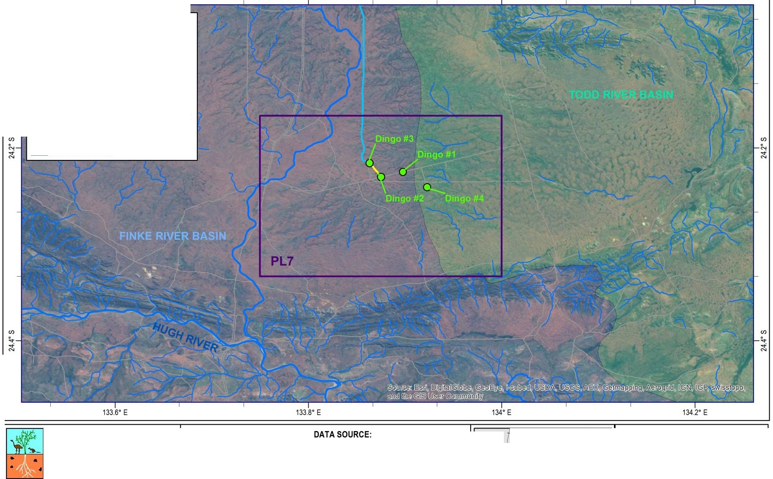

-'---

C> copyright Map compiled Feb 2014 by RW. Eded June 2014 by RW.Ref C:IROZIGIS\Maps\Mageln\FEMP\Hydrology\Hydrology

|  |  |  |  |
| --- | --- | --- | --- |
| For further information, please contact: PROJECTION:  Low Ecological Services P/L LaULon hddd.ddddd• Background:  Phone: (08) 89555 222 HORIZONTAL DATUM: ESR,I DigitaiGiobe, Geoeye, i-cubed,USDA, wwwl.owecol.coma. u Geodetic Datum of Australia 1994 USGS, AEX,Getmapping,Aerogr d,IGN, IGP,  ILo w E co Io g ic a I S erv ices P I L 1 1--- _--=:==..  [lowecol@lowecol.com.au](mailto:lowecol@lowecol.com.au) swisstopo, and the GIS User Community  0 3 6 12  Kilometers A Scale: 1: 300,000 | *i>-* AUCE SPRNI GS  *if*  *l*  1 NT | QLD | Dingo Gas Field Development project  Surface Hydrology |
| SA | |
|  |  | |  |

Figure 5.1:PL7 in relation to surface hydrology

Low Ecological Services Pty. Ltd. June 2014 Page 12

133.6" E 133.8" E 134" E

Legend

0 Eremophila prostrata records

0 Existing Wells

-+--- Adelaide-Darwin Railway

-- Proposed Dingo Pipeline

Proposed Dingo #2 Wellhead Flowline

-Existing Access Tracks

c:J Production Licence Application Area

Vegetation Class (Wilson et al.,1991)

- 66

- 71

- 73

- 83

- 87

For further information.please contact: PROJECTION: DATA SOURCE: Dingo Gas Field

n i5 rs P/L

[www.lowecol.com.au](http://www.lowecol.com.au/) [lowecol@lowecol.com.au](mailto:lowecol@lowecol.com.au)

LaULon hddd.ddddd•

HORIZONTAL DATUM:

Geodetic Datum of Australia 1994

Background:

ESRI.DigitaiGiobe. Geoeye.i-cubed.USDA. USGS, AEX. Getmapping.Aerogrid, IGN,IGP.

Development project

Vegetation Classes

ILo w E co logical Services P / L I

swisstopo.and the GIS User Community

N

NT QLD

(Wilson et a.l,1991) and

*Eremophi/a prostrata* Records

0 2.5 5 10 ' Scale: 1: 250,000 SA

Kilometers A

(Atlas of living Australia)

Q copyr hlMap comled Feb 2014 by RW.Edled June 2014 by RW.Ref CIROZIGIS\Maps\Magel \FEMP\Veg\Veg_E_prostrala

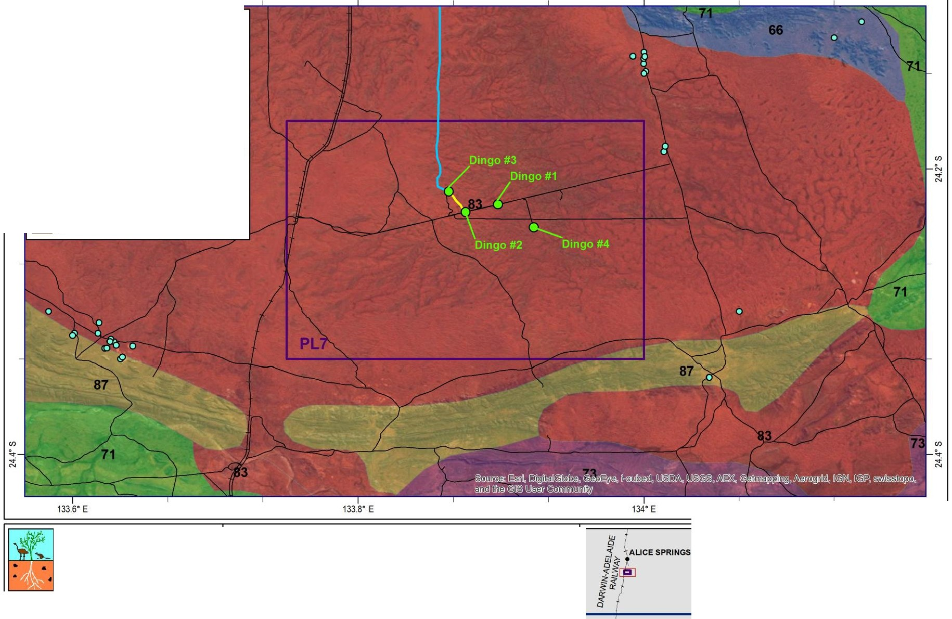

Figure 5.2:Vegetation Classes (Wilson et al.,1991) and records of *Eremophila prostrata* from the Atlas of living Australia.

low Ecological Services Pty. ltd. June 2014 Page 13

**6. ENVIRONMENTAL MANAGEMENT MEASURES**

The Dingo Gas Field Development Project will be managed within the broader framework of Central

Petroleum Limited’s Health, Safety and Environment Integrated Management System.

A risk assessment is included in the Field Environmental Management Plan. The risk assessment identifies all potential hazards, assesses the likelihood of those hazards to impact the environment and provides management measures for managing the risk to as low as reasonably practicable.

The risk assessment did not identify any high risks once management measures were taken into consideration. The most significant risks associated with the project are:

• Ingress of weeds; and

• Erosion or movement of sediment.

Both the above are risks resulting from earthworks and increased use of the project area.

The following standards are extracts from the Field Environmental Management Plan and show the management measures Central Petroleum (NT) Pty. Ltd. will employ to manage these risks in the broader context of preventing land degradation and the loss of biodiversity. In addition to these standards, Central Petroleum (NT) Pty. Ltd. has developed a Weed Management Plan and an Erosion and Sediment Control Plan for the wider Dingo Gas Field Development Project. Both plans have been submitted to the Department of Mines and Energy for approval.

**Environmental Management Standard 1: Land**

|  |  |
| --- | --- |
| **Objective:** | To prevent land degradation as a result of activities conducted in production licence area. |
| **Measurement**  **Criteria:** |  No evidence of unauthorised vegetation clearing or earthworks;   No evidence of unauthorised access;   All areas of erosion or compaction adequately controlled;   All areas of potential erosion adequately controlled;   No evidence of hydrocarbon contamination of soil;   Adequate rehabilitation of areas no longer required for safe operations following construction;   Compliance with all other environmental management strategies, particularly  Water, Waste and Biodiversity Management Strategies; and   Records of site inductions show 100% participation by all personnel, contractors and visitors. |
| **Management**  **Measures:** | • Areas to be disturbed to be surveyed by a qualified environmental consultant  • Areas authorised to be disturbed clearly communicated to earthworks crew  (maps, GPS etc.)  • No unauthorised access policy developed and implemented (includes “no off road driving”, “no off road or offsite parking”)  • Design of equipment and infrastructure to be in accordance with relevant legislation and industry and Australian standards as required by the legislation  • Oil Spill Contingency Plan developed and implemented  • Emergency Response Plan developed and implemented  • Spill prevention measures: bunding, drip trays, spill response kits  • Adherence to the Dingo Gas Field Development Project Erosion and Sediment  Control Plan  • Compulsory site inductions for all personnel, contractors and visitors prior to entering the site. |

**Environmental Management Standard 2: Biodiversity**

|  |  |
| --- | --- |
| **Objective:** | To prevent a loss of biodiversity as a result of activities conducted in production licence area. |
| **Measurement**  **Criteria:** |  Environmental clearance conducted prior to disturbance;   No evidence of unauthorised vegetation clearing or earthworks;   No evidence of unauthorised access;   No evidence of hydrocarbon contamination of soil or water;   Adequate rehabilitation of areas no longer required for safe operations following construction;   No new weed infestations;   Declared weeds managed in accordance with the *Weed Management Act*;   Records of daily vehicle inspections;   Compliance with all other environmental management strategies, particularly  Water, Waste and Land Management Strategies; and   Records of site inductions show 100% participation by all personnel, contractors and visitors. |
| **Management**  **Measures:** | • Adherence to the Dingo Gas Field Development Weed Management Plan  • All vehicles, equipment and machinery cleaned and inspected for weeds prior to mobilisation to site, records to be maintained.  • Check and remove excess vegetation from grill, tyres and under-tray during daily vehicle inspection. Also check when traversing/departing areas of weed infestations  • If soil or gravel is brought on site such as for hardstand areas, it must be sourced from a weed free area.  • Obtain and follow advice from either a qualified consultant or NT Weeds  Management Branch prior to controlling weed infestations  • Areas authorized to be disturbed are clearly mapped and communicated to clearing crew including flagging (not painting) large/slow growing/cultural significant trees and habitat features (tree hollows, burrows etc.) that are not to be cleared.  • Maximise use of existing areas of disturbance;  • Stockpile vegetation and topsoil separately and in low piles for use in rehabilitation  • Identification of significant flora species and significant fauna species habitat included in site inductions and ID booklets readily available on site.  • Designated equipment/material laydown and vehicle turnarounds areas implemented.  • Speed limited to 60km per hour on unsealed access track to minimise risk of fauna injury/fatality resulting from vehicle collision  • Avoid driving at dawn, dusk and night. |

Other risks identified, with corresponding standards, in the Field Environmental Management Plan relate

to:

• Water Management;

• Waste Management;

• Noise Management;

• Air Quality Management;

• Fire Management; and

• Complaints Management.

**7. CONSULTATION**

The proponent has undertaken extensive consultation with landholders, Traditional Owners and the

Central Land Council in relation to the proposed Dingo Gas Field Development Project.

The proponent has also liaised directly with various NT government departments to determine the level of information required for the relevant departments to assess the project.

Central Petroleum (NT) Pty. Ltd. will make itself available for consultation with relevant government authorities, interested persons or organisations as required and will ensure Central Petroleum (NT) Pty. Ltd.’s contact details are made publicly available. Any complaints will be recorded and managed in accordance with Central Petroleum (NT) Pty. Ltd.’s complaints management strategy and Central Petroleum Limited’s Health, Safety and Environment Integrated Management System. incident reporting and investigation procedures.

**8. REFERENCES**

Atlas of Living Australia, 2014. *Atlas of Living Australia web site.* [Online] Available at: [www.ala.org.au](http://www.ala.org.au/) [Accessed May 2014].

Perry, R.A., Mabbutt, J.A., Litchfield, W.H. & Quinlan T, 1962. *Land Systems of the ALice Springs Area ot the*

*Northern Territory.* Canberra: CSIRO.

Wilson, B.A., Brocklehurst P.S., Clark, M.J. & Dickinson, K.J.M, 1991. *Vegetation Survey of the Northern*

*Territory Australia.* Darwin: Conservation Commission of the NT.