

Filename: NT-ENV-GEN-REP-001 Env Plan Summary

Page 1 of 6

Rev

Status

Prepared by

Checked by

Approved By

Date

A

For Review

Michael Kelly

Jon Martin

Roger Cressey

10/9/2013

**Document Title**

**Myrtle Basin - 1 Environment Plan Summary**

**Document Number**

**NT-ENV-GEN-REP-001**



**CONTENTS**

1

Coordinates and locality maps (legible and at appropriate scale) of the activity ..................... 3

2

Description of the activity ....................................................................................................... 3

3

Description of the environment where activity will occur......................................................... 4

4

Description of the activity in relation to the environment

(including best environmental practice) .................................................................................. 4

5

State major environmental hazards and risks; describe hazard/risk assessment process

and controls measures........................................................................................................... 5

6

Provide an overall description of the environmental management approach .......................... 6

7

Advice on consultation undertaken and provision for ongoing consultatioN ........................... 6

8

State contact details of operator’s nominated liaison personnel for the activity ...................... 6

Filename: NT-ENV-GEN-REP-001 Env Plan Summary

Page 2 of 6

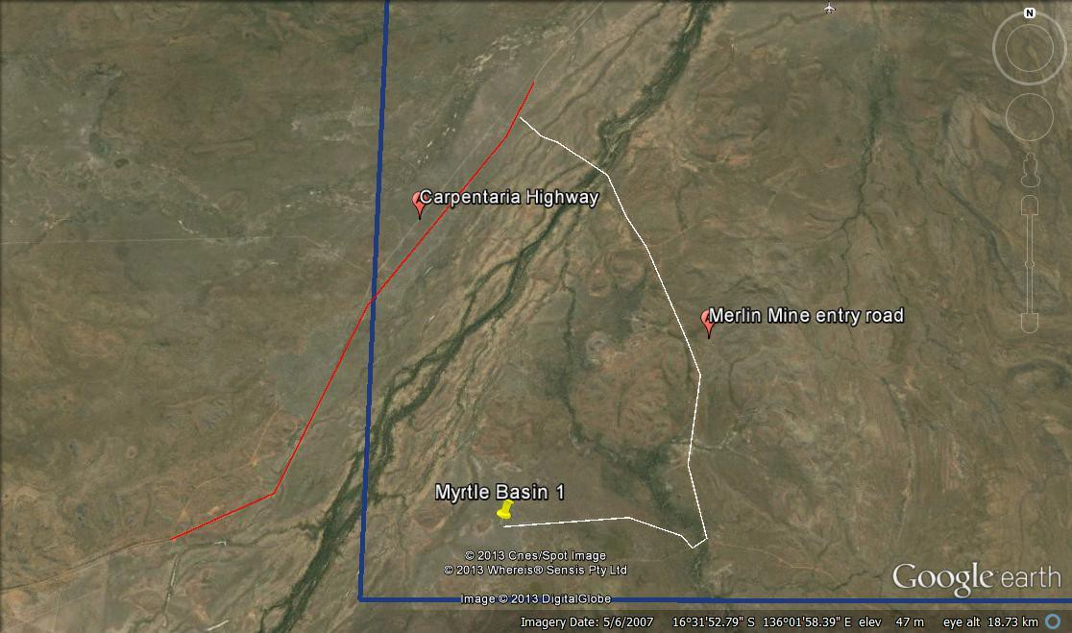

**1**

**Coordinates and locality maps (legible and at appropriate scale) of the activity**

**2**

**Description of the activity**

Armour Energy Ltd, as Tenement Holder and Operator, proposes to drill a series of vertical

exploration holes in the McArthur Basin of the Northern Territory, approximately 750 km south

East of Darwin and 700 km North West of Mt Isa. These holes are proposed as exploration wells targeting the Barney Creek Fm and Teena/Coxco Dolomite within the Umboolooga Sub-

group of the McArthur Group in the Batten Trough area. The drilling is expected to commence

13 September 2013 and be completed by 27th September 2013. The well is viewed as a relatively simple drilling activity and no issues are predicted to cause concern or delay during the activity.

Filename: NT-ENV-GEN-REP-001 Env Plan Summary

Page 3 of 6

**GDA94 - Zone53**

**Well name**

**X mE**

**Y mN**

**Lat**

**Long**

**Myrtle Basin 1**

609499

8167793

-

16.5695

136.0263



The objective of the exploration program is to delineate a hydrocarbon resource of

conventional and unconventional gas from the dolomites and shales found within the Batten

Fault Zone of the McArthur Basin and to provide data on geological structures.

It is proposed to achieve this objective by using open-hole air-mist drilling techniques and wire line logging and in-process and post-drilling testing of the wells to test the formations for presence of hydrocarbons and flow potentials.

The activity will use a UDR 1200 Drill Rig which has capacity to safely undertake the above activities. The drilling activity is fully risk assessed with the Operator and Contractor having copies of the risk assessment.

A basic construction crew will undertake construction of leases which are 100m x 100m with three drilling sumps and a flare pit. The machinery used will be a Cat 140 Grader, Cat D7G Dozer, ~25t Excavator, a Cat Loader and up to two water tankers for construction and maintenance as required. Rig crews will be housed at Heartbreak Hotel – Cape Crawford.

**3**

**Description of the environment where activity will occur**

The wells are located in the transition zone between tropical and arid zones, the sites are

immediately south-west of the township of Borroloola, 460 km south-east of Katherine.

The McArthur River lies on the eastern side of the Site and the rugged rocky sandstone hills of the north Bukalara Range dominate its centre east. The Site also contains near-permanent water at Caranbirini Waterhole. Apart from riparian vegetation along the McArthur River and associated watercourses, the hills and surrounding areas are mostly vegetated by open eucalypt woodland with a grassy understorey. Largely the land systems are ecologically consistent throughout the tenement area.

The majority of the land is part of the McArthur River Station Perpetual Pastoral Lease and is used primarily for cattle grazing. To the east is the Spring Creek Pastoral Lease and this land is dominated by the Bukalara Range and also used for cattle grazing.

The nearest community is the township of Borroloola. Borroloola is dominantly a service community for the nearby Xstrata McArthur River Zinc Mine and associated port facilities at Bing Bong and the surrounding cattle grazing stations.

Within the area sites of indigenous Cultural Sensitivity are known to exist and Armour Energy has implemented a cultural heritage management agreement with the Northern Land Council and the local Aboriginal Group under a Native Title Agreement.

**4**

**Description of the activity in relation to the environment (including best**

**environmental practice)**

The exploration activities of Armour Energy are not expected to cause undue disturbance.

Armour will use best practice in terms of minimising construction footprint and minimising waste generation. The number of wells forecast to be drilled, by area, is forecast to be less than <0.05% of the tenement area. The sites have been chosen where possible to sit on existing seismic lines and even on existing exploration leases. Armour Energy have chosen to engage with local contractors where possible minimising exploration related traffic and accommodation to the region.

Filename: NT-ENV-GEN-REP-001 Env Plan Summary

Page 4 of 6



Establishment of the sites will recognise the environmental values and will incorporate the

advice of qualified third party expertise in terms of the site assessment.

Equipment has been engaged to manage road maintenance (including dust suppression) from local contractors.

Waste will be disposed to approved local waste facilities and regulated waste will be disposed in consultation with the local authority in accordance with their requirements to the respective approved facility.

Rehabilitation will be in accordance with the principles set out in the approved Armour Energy Environmental Management Plan. The rehabilitation process will be designed to return sites, where designated, to a condition consistent with the neighbouring land form, vegetation and drainage. Rehabilitation will take into account any related advice from Armour Energy’s third party consultants.

Monitoring will be undertaken in accordance with the recommendations of the third party consultants and will follow the requirements set out in the Armour Energy Rehabilitation Monitoring procedure as a minimum.

**5**

**State major environmental hazards and risks; describe hazard/risk assessment**

**process and controls measures**

A risk assessment is included in the environmental management plan. The risk assessment

was reviewed by a qualified person and has been peer reviewed within Armour Energy. The risk assessment lists all identified potential hazards and their respective treatment processes

to reduce the likelihood of an unplanned event occurring which may damage the environment.

No issues were identified in the risk assessment which, after treatment, would likely cause environmental harm outside the provisions of the controls in the Environmental Management Plan.

All hazard’s assessed (and controls) are clearly listed in the Risk Assessment in the Environmental Management Plan. Some of the more critical Major hazards which were assessed are:

Fuel & Oil Spill: Diesel storage on site is minimised to 5000L, main 60,000L storage is located

at the central lay down yard in a double bunded hire storage tank. No waterways are within

one kilometre of the storage locations.

Clearing protected flora: use existing seismic lines for all activities where possible. Undertake

flora survey for all virgin stands. No activities allocated for sensitive areas and national parks.

Clearing protected fauna habitat: use existing seismic lines for all activities where possible.

Undertake flora survey for all virgin stands. No activities allocated for sensitive areas and

national parks. Undertake fauna survey to try to define if there are any protected species in the vicinity.

Cultural heritage: All areas selected for exploration are scouted by approved Cultural Heritage

stakeholders prior to commencement. Approved Cultural Heritage Monitors on site at all times

where possible to observe and approve activities.

Filename: NT-ENV-GEN-REP-001 Env Plan Summary

Page 5 of 6



**6**

**Provide an overall description of the environmental management approach**

Armour Energy will undertake its

Environmental Practice 2008. The constructed using this Code as its

activities in compliance with the APPEA Code of

Armour Energy Environmental Management Plan is guide and incorporates the additional directions from

NTDME. Further, specific local requirements resulting from consultation with Traditional

Owners, Local Government, Landholders and Environmental Consultants are all captured within the Environmental Management Plan.

At a basic level Armour Energy will seek to minimise its footprint by taking advantage of existing roads and tracks, only build leases suited for the job thereby minimising land clearing. All areas are assessed and monitored by people who are qualified and rehabilitation will be in accordance with the APPEA Code of Environmental practice and specifications set by qualified third parties. Site rehabilitation will be monitored for effectiveness in accordance with Armour Energys Rehabilitation Monitoring Procedure.

**7**

**Advice on consultation undertaken and provision for ongoing consultatioN**

Extensive consultation has been undertaken in the region particularly with Traditional Owners on a number of occasions (ongoing). The following people have been consulted with in respect of this campaign:

o Northern Land Council (NLC),

▪

Closed forums with Traditional Owner people who speak for the various areas

to be drilled.

Open forums in Borroloola.

Forums which include representative Anthropologists.

Ongoing NLC consultation (weekly) informing them of progress and any matters raised by the Monitors.

▪

▪

▪

o Landholders and Neighbouring Mine Operators.

o Northern Territory Department of Mines and Energy.

o Local Government (Council).

o Local businesses.

**8**

**State contact details of operator’s nominated liaison personnel for the activity**

Contact: Roger Cressey – General Manager Operations & Projects

Ph: +61 7 3303 0620

Mob:

0419 663 569

Email: [rcressey@armourenergy.com.au](mailto:rcressey@armourenergy.com.au)

Filename: NT-ENV-GEN-REP-001 Env Plan Summary

Page 6 of 6