

**MANBULLOO-S1**

**STRATIGRAPHIC DRILL HOLE**

**ENVIRONMENTAL PLAN SUMMARY**

**TABLE OF CONTENTS**

**1. INTRODUCTION ..........................................................................................................................................3**

**2. DESCRIPTION OF ACTIVITY..........................................................................................................................4**

**3. DESCRIPTION OF THE ENVIRONMENT.........................................................................................................4**

**4. DESCRIPTION OF THE ACTIVITY IN RELATION TO THE ENVIRONMENT ........................................................5**

**5. ENVIRONMENTAL RISKS OF PROPOSED ACTIVITY AND CONTROL MEASURES ............................................5**

**6. CONSULTATION ..........................................................................................................................................6**

**7. PANGAEA RESOURCES LIAISON PERSONNEL...............................................................................................6**

**1. INTRODUCTION**

EP167 is located approximately 350 km southeast of Darwin in the Northern Territory (NT) in the western McArthur Basin. The basin is essentially unexplored for hydrocarbons, either conventional or unconventional, and from a shale gas or oil perspective, there is limited information on thermal maturity, Total Organic Carbon (TOC), porosity, permeability, gas content or saturation. The tenement falls within the Victoria-Daly, Roper and Barkley Shires plus the Katherine Municipality.

The proposed Manbulloo-S1 stratigraphic drill hole will be located in the north western portion of EP167 in central Northern Territory, approximately 55 km south of Katherine and approximately 50 km west of the Stuart Highway. A location map and coordinates of the activity are provided in Figure 1.

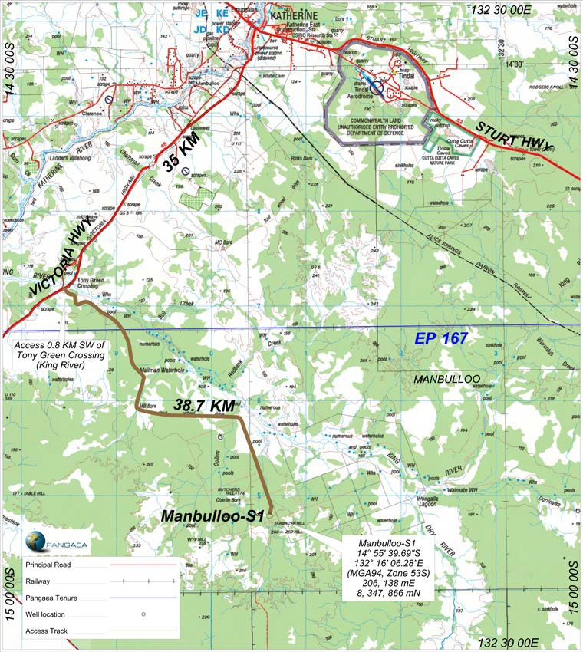

***Figure 1: EP-167 Manbulloo-S1 Drill Hole site***

**2. DESCRIPTION OF ACTIVITY**

The objectives of the Manbulloo-S1 Drill Hole in EP167 are to:

• Identify thick intervals of organic-rich shale within the wet to dry gas hydrocarbon generation windows;

• Confirm the stratigraphy and tie this stratigraphy to the regional seismic interpretation;

• Collect velocity information to improve the time to depth conversion for the regional seismic interpretation; and

• Evaluate the thermal maturity, gas content, gas saturation, gas composition, mineralogy, porosity and permeability of the shale units within the McArthur Group from core and wireline logs.

By way of summary, the evaluation proposed for the site will also comprise of coring and wireline logging operations. The final well will not be used to produce oil and gas, therefore Pangaea will plug and abandon Manbulloo-S1 by cementing the well from Total Depth (TD) to surface to isolate all porous formations, aquifers and potential reservoirs.

**3. DESCRIPTION OF THE ENVIRONMENT**

The region’s climate is ‘semi-arid tropical, with rainfall concentrated in the wet season months between November and April. Though rainfall can be variable from year to year, there is a distinct gradient of decreasing mean annual falls from 850mm in the north to less than 500mm’ in southern areas of EP168, with nearly all the rainfall occurring between November and April1, 2. The mean maximum temperature varies from 27°C in July to 40°C and beyond in November.

Condition is generally good across much of the bioregion, reflected in a continental stress class score of 5. However, as one of the most fertile areas in northern Australia, and because of its proximity to Darwin and Katherine, the bioregion is one of the most developed in the Northern Territory. About 8% of the region has been cleared for horticultural production or intensive grazing, and more extensive development is being proposed3.

The Manbulloo-S1 drill site is located within the Tagoman land system. This land system consists of plains and rises on weathered and unweathered Cambrian limestone, sandstone and siltstone with associated sand sheets; sandy and earth soil. Soils are generally of variable depth comprised of red earth soils with gravel. Mixed eucalypt woodlands and perennial grasses grow in this area. The systems are generally suitable for pasture improvement and have moderate to high grazing potential. The Tagoman land system consists of vegetation that have a relatively low forage quality in the dry season but it can benefit from strategic burning to manage woody thickening4.

1 Williams et al (1997) ‘Torch, trees, teeth and tussocks’ in *Frontiers in Ecology, Building the Links*. Eds. N. Klomp and I. Lunt. Elsevier, Oxford: pp55-66.

2 Hennessy et al (2004) *Climate Change in the Northern Territory*, CSIRO, Melbourne, Victoria.

3 Department of Land & Resource Management (2014) Daly Basin – Bioregional Description. Downloaded at <http://lrm.nt.gov.au/plants-and-animals/herbarium/nature/bioregional/dalybasin#.U5RknV5Rf1o>

4 Northern Territory Government (no date) Land Condition Guide – Sturt Plateau District, Understanding the productivity of grazing lands. Produced in association with the Northern Territory Cattlemen’s Association as part of the Caring for Our

Country project ‘Grazing Land Management – Demonstration, Continuation and Evaluation’.

**4. DESCRIPTION OF THE ACTIVITY IN RELATION TO THE ENVIRONMENT**

The Manbulloo-S1 stratigraphic drill hole has been designed with due consideration of the surface and subsurface environments. The site has been designed and will be constructed to avoid large scale levelling and clearance of vegetation.

The well has been designed to:

• Isolate permeable zones within the well;

• Protect potable water aquifers;

• Prevent uncontrolled discharge of water, gas or oil from the well while drilling; and

• Prevent cross flow between potential aquifers, reservoirs or formations.

These objectives are achieved by the appropriate selection of:

• Surface equipment (including drilling rig and well control equipment);

• Surface facilities/pits for the containment of drilling fluids;

• Casings and setting of casing depths to ensure aquifers are isolated;

• Drilling techniques;

• Down hole technology; and

• Well completion procedures.

**5. ENVIRONMENTAL RISKS OF PROPOSED ACTIVITY AND CONTROL MEASURES**

**Fauna and flora**

Potential impacts to surrounding flora and fauna at the well site will be assessed and reduced by measures including weed and pest inspections on all vehicles and personnel clothing prior to arrival at site, the use of signage and appropriate fencing.

**Groundwater**

The well will be grouted and completed according to industry best practice sealing requirements. Any well that encounters an artesian or sub-artesian flow will be sealed to prevent contamination or cross- contamination of aquifers and will be sealed with cement plugs to prevent surface discharge of groundwater. Appropriate sedimentation and erosion control measures will be put in place at the well site. The amount of hazardous material stored and used on site shall be kept to a minimum.

**Noise and surface**

Speed limits will be enforced on access tracks to limit and minimise dust and noise generation. Vehicular movements to and from the work site will be minimised by travel during daylight hours and be compliant with land access agreements. Soil erosion will be minimised by the use of existing tracks, deviating around creeks, river banks and naturally formed depressions and not accessing roads in wet conditions.

**Waste management**

Waste will be stored in suitable receptacles and disposed of accordingly at municipal managed locations. Hazardous material shall be transported, stored and handled in accordance with the requirements of the relevant legislation and guidelines.

**6. CONSULTATION**

During the past several months Pangaea has consulted with stakeholders, which has included:

• A detailed cultural heritage assessment and clearance process with the Northern Land Council and

Traditional Owners;

• Signing voluntary access agreements with Pastoralists;

• Involvement in joint NTDME-APPEA-CSIRO public forums and information nights held in major towns and centres in NT;

• Notifying local government councils, police authorities and local businesses of exploration activities; and

• Complying with legislation and guidelines from the NT Department of Mines and Energy.

Pangaea’s engagement aimed to identify and address any issues of concern, reach agreement and in general engage in goodwill communication.

Pangaea will continue this process with stakeholders throughout the life of the project.

**7. PANGAEA RESOURCES LIAISON PERSONNEL**

|  |  |  |
| --- | --- | --- |
| **Sydney Office** | | |
| External Affairs Manager | [Ricky.Mantaring@pangaea.net.au](mailto:Ricky.Mantaring@pangaea.net.au) | Phone: (02) 9017 9600 |