Dalabon plants and animals book complete after 19 years research.

After 19 years of cross-cultural research Dalabon elders and Northern Territory Government scientists have completed a book that conserves and promotes Dalabon knowledge of over 560 plants and animals. The 256 page book includes drawings of over 250 plants and animals and many colour photographs of plants and animals, landscapes, hunting signs and elders from Dalabon country.
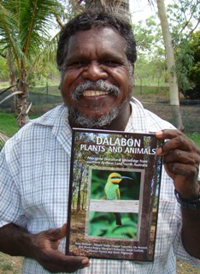
'Passing on biocultural knowledge is one of the key cultural obligations for Aboriginal elders in Australia. This book will be a continuing conduit of flora and fauna knowledge for Dalabon elders and all future generations' says co-author and ethnobiologist Glenn Wightman in the preface.
The book includes detailed insights into ancient and complex Dalabon knowledge, such as knowledge of the now extinct thylacine or Tasmanian Tiger, and images of discrete species-specific hand-signs used by Dalabon hunters.
The book preparation was a collaboration between Dalabon elders, the Northern Territory Government, Mimi Aboriginal Art & Craft, Diwurruwurru-jaru Aboriginal Corporation and the Australian Institute of Aboriginal and Torres Strait Islander Studies. It can be purchased from Mimi Aboriginal Art & Craft, phone 08 8971 0036, email community@mimiarts.com

