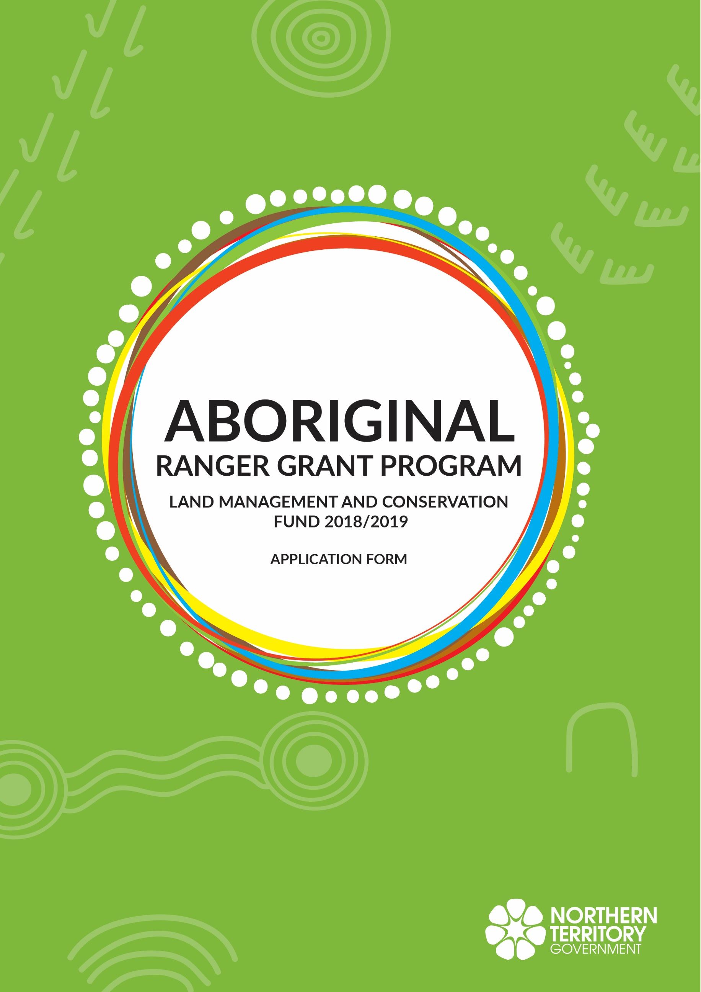

Contents
Land Management and Conservation Fund Application 4
Parties to the Application 4
The Applicant 4
Joint Applicants 4
Applicant’s representative and address: 5
The Northern Territory 5
Northern Territory representative and address: 5
Background 5
Submission 5
Application Details 6
Land Management and Conservation Fund 6
Project Summary 7
Project Title: 7
Description of the Project: 7
Outcomes to be achieved: 7
Project Context: 7
Ongoing Benefit: 7
Co-contributor: 7
In-Kind Support: 7
Permits and/or Approvals: 7
Capacity to Deliver: 8
Conflict of Interest: 8
Project Activities 9
Activity One 9
Activity Description 9
Description 9
Resources 9
Staffing 9
Outputs/Milestones and Budget Cost Table 10
Additional Project Details 12
Risk Assessment: 12
Payment: 12
Acquittal: 12
Reporting: 12
Record Keeping: 12
Signatures 13
Company Applicant 13
Incorporated Association Applicant 13
Partnership Applicant 14
Appendix 1 15
Risk Matrix, consequence and Likelihood Tables 15
Risk Matrix 15
Likelihood Table 15
Consequence Table 15

Land Management and Conservation Fund Application
Once completed, this document, together with the Grant Agreement and the Northern Territory General Grant Conditions (Schedule 1) will form an Agreement between the Northern Territory and the Applicant.

Parties to the Application

The Applicant
Full legal name of Applicant
Legal entity type (e.g. registered organisation, incorporated association, company, partnership)
Any relevant licence, registration or provider number
Australian Business Number
Registered for Goods and Service Tax (GST)?
Registered office (physical/postal)
Relevant business place (if different)
Telephone
Facsimilie
Mobile
Email
Bank Details
Bank Account Name
Bank BSB
Bank Account Number

Joint Applicants
If joint application please provide the following information for all joint applicants (If more than one joint applicant please provide details for all other joint applicants in a separate attachment).
Full legal name of Joint Applicant
Legal entity type (e.g. registered organisation, incorporated association, company, partnership)
Any relevant licence, registration or provider number
Australian Business Number
Registered for Goods and Service Tax (GST)?
Registered office (physical/postal)
Relevant business place (if different)
Telephone
Facsimilie
Mobile
Email

Applicant’s representative and address:
Applicant’s representative name
Position
Physical/postal address/es
Business hours telephone
Facsimilie
Mobile
Email

The Northern Territory
The Northern Territory of Australia Represented by:
Department of Environment and Natural Resources
PO Box 496
Palmerston NT 0831
Australia
ABN 84 085 734 992

Northern Territory representative and address:
Northern Territory representative name | Mr Keith Saalfeld
Position | Director, Aboriginal Ranger Grants Program
Business hours telephone | 08 8995 5039
Facsimilie | 08 8995 5099
Mobile | 0447 830 097
Email | keith.saalfeld@nt.gov.au

Background
The Northern Territory is seeking applications from Aboriginal ranger Groups and organisations for grant funding under the Protecting Country, Creating Jobs initiative. Grants can be used to support rangers and land managers in achieving land and sea management and conservation outcomes on Aboriginal land.

Submission
Application can be submitted either by:
- Email to rangergrants.DENR@nt.gov.au; or
- Postal via Department of Environment and Natural Resources
Aboriginal Ranger Grants Program
PO Box 496
Palmerston NT 0831
Australia
Applicants should note that email submission is preferred. If applicants submit a printed and signed copy of the application, they are requested to also submit an unsigned digital copy via email.

Application Details

Land Management and Conservation Fund
The purpose of the grant under the Land Management and Conservation Fund is to undertake the Project specified in these Application Details.
This Grant will be provided as part of the Northern Territory Aboriginal Ranger Grants program – Land Management and Conservation Fund.
Applications can be for either single-year Projects with a total value up to $100,000 or for multi-year Projects with a total value of up to $300,000 over 2 years or $500,000 over 3 years. Applications for Projects exceeding these values should only be submitted after consultation with Aboriginal Ranger Grants Program Director.
Applicants should ensure that they read the instructions associated with each field carefully before entering any text.

Project Summary

Project Title:
Enter a descriptive Project Title (preferred max 20 words).

Description of the Project:
Describe the project objectives including how the project will be carried out, who will be involved, any major partners and links to other projects [refer Section 5.3 of the Guidelines] (preferred max 300 words).

Outcomes to be achieved:
Describe the land and/or sea management and conservation outcomes that will be supported/achieved by the project. Applicants are encouraged to provide a SMART statement to describe the outcomes of the project. The outcome(s) should be Specifically described, have a quantifiable Measure of achievement, be something that is Attainable, be a Realistic outcome of the project and have a clear Time frame for the outcome [refer Section 5.3 of the Guidelines] (preferred max 500 words).

Project Context:
Describe how the project contributes to identified Regional, Territory or National priorities, e.g., in a Management Plan, Regional INRM Plan, Threatened Species Recovery Plan [refer Section 5.3 of the Guidelines] (preferred max 250 words).

Ongoing Benefit:
Describe how the positive benefits from this project will be maintained after the funding period [refer Section 5.3 of the Guidelines] (preferred max 300 words).

Co-contributor:

Name:_________________________________________ Amount:______________ GST inc/exc
Agreement details:
Provide details of the funding agreement between the Applicant and the Co-contributor. A copy of the signed agreement or the application for co-contribution funding should be submitted with this application (refer Section 3.3 of the Guidelines).
Payment schedule:
Provide details of the co-contribution payment schedule if other than a single payment.

In-Kind Support:
Detail any in-kind support that will be provided by the applicant [refer Section 5.3 of the Guidelines] (preferred max 150 words). If nothing specific enter N/A.

Permits and/or Approvals:
Provide details of any permits and/or approvals that may be required for the project to be successfully implemented (e.g., permit/approval under the Land Rights (NT) Act, Territory Parks and Wildlife Conservation Act or Environment Protection and Biodiversity Conservation Act) [refer Section 5.3 of the Guidelines] (preferred max 150 words). If nothing specific is required enter N/A.

Capacity to Deliver:
Describe how the applicant has the capacity to deliver the project on time and on budget with consideration of available staff and resources, governance arrangements, project and work planning and project administration [refer Section 5.3 of the Guidelines] (preferred max 300 words).

Conflict of Interest:
Detail and actual, apparent or potential conflict of interest that may impact on this application [refer Section 4.5 of the Guidelines] (preferred max 150 words).

Project Activities
A project may have one or more major activities. Complete this section for each activity; for more than one activity copy and paste the tables below as required.
To copy select from the Activity One heading to the end of the Output/Milestones and Budget Cost table below. Paste the copied section after the Output/Milestones and Budget Cost table. Repeat as required for each of the major activities that make up the project. The copy and paste should be done prior to entering any text in the tables. When completed edit the Activity One heading on the copies to Two, Three etc as appropriate.
For projects with more than three major activities, applicants should give consideration to splitting into separate projects and submitting an application for each.

Activity One

Activity Description
Description | Describe the activity to be undertaken from start to finish, including consultation, operational planning, purchase of materials, on-ground actions, monitoring and reporting, and the commencement and completion dates on an annual basis for the activity [refer Section 5.5 of the Guidelines] (preferred max 250 words).
Resources | List the resources required to undertake the activity, including in-kind, co-contributor and grant funded (preferred max 150 words).
Staffing | List the staff and time commitments to undertake the activity, including in-kind,co-contributor and grant funded. If grant funding is to be used to employ ranger staff, pay for traditional owner time or pay for consultants; each must be identified as a specific output/milestone below and fully explained/documented with justification (may be attached separately). Refer Section 5.3 of the Guidelines (preferred max 150 words).

Outputs/Milestones and Budget Cost Table
For the output/milestone Description give a concise description of the specific output/milestone that contributes to the performance assessment and budgeting for the activity, e.g., aerial spraying of Mimosa pigra of the floodplain [refer to Section 5.3 of the Guidelines] (preferred max 30 words).
For the output/milestone Measure give a concise description of the quantitative measure used to the achievement of the output/milestone, e.g., 50 Ha of floodplain sprayed for Mimosa pigra annually [refer to Section 5.3 of the Guidelines] (preferred max 30 words).
Start Date and Finish Date are the dates that any actions/activities associated with the output/milestone are to commence and will be completed.
Budget Year 1, Budget Year 2 & Budget Year 3 are the budget amount being sought in grant funding associated with the particular output/milestone in years 1, 2 & 3 for the project activity. If a single year project fill in year 1 only, for multi-year projects fill in years 1, 2 & 3 as appropriate. All amounts are to be the GST exclusive amount.
Proportion of Co-contributions and In-kind Support are the budgeted amount of each item for the project activity in years 1, 2 & 3. Co-contributions and in-kind support should be described in the Project Summary above and the specific contribution of each to the project activity in the Resources and Staffing of the Activity Description table above.
The output/milestones and budget cost table has space for six outputs/milestones to be entered.
If there are more outputs/milestones for the project activity than can be fitted in the table, copy and paste a second output/milestones and budget table below the first and insert the additional output/milestones and budget costs in it.
Proportion of Co-contributions and In-kind Support should only be entered into the second/last table. The first item of the second/last table should be Sub-total Project Activity Grant Funding from table one above and the budget values for Years 1, 2 & 3 from table one for Subtotal Project Activity Grant Funding entered here. Measure, Start and Finish Date should be left blank for this item.
The Description and Measure fields in the output/milestones and budget cost table are fixed size and able to display about 30 words of text. Additional text can be entered but will not be displayed or printed. This text will be saved and will be available for review in the digital copy of the application.
To edit the table, right click on the table and select Worksheet Object Edit from the popup menu that appears. Enter information and to finish editing click elsewhere on the application.

Additional Project Details

Risk Assessment:
Identify, rate and assess the likelihood of any risks that may impact on the delivery of the Project and identify risk mitigation measures or strategies to manage identified risk. Copy and add additional rows to the table below as required. See Appendix 1 for Risk matrix example for assistance in assessing Likelihood, Consequence and Rating. For Mitigation you should describe strategies that will reduce likelihood and/or consequence to reduce the rating.
Risk | Likelihood | Consequence | Rating | Mitigation
Describe the risk and impact on project (preferred max 100 words). | See Appendix 1. | See Appendix 1. | See Appendix 1. | Describe the controls to manage the risk.
Describe the risk and impact on project (preferred max 100 words). | See Appendix 1. | See Appendix 1. | See Appendix 1. | Describe the controls to manage the risk.
Describe the risk and impact on project (preferred max 100 words). | See Appendix 1. | See Appendix 1. | See Appendix 1. | Describe the controls to manage the risk.

Payment:
Payment will be made in accordance with the requirements detailed in the Grant Details of the Grant Agreement.

Acquittal:
The Applicant agrees to acquit the funds in accordance with the requirements detailed in the Grant Details of the Grant Agreement.

Reporting:
The Applicant agrees to provide reports in accordance with the requirements detailed in the Grant Details of the Grant Agreement.

Record Keeping:
The Applicant agrees to maintain appropriate records in accordance with the requirements detailed in the Grant Details of the Grant Agreement.

Signatures
Company Applicant (if the Applicant is a Company)

Name of Company

Directors Name (PRINT): _____________________________________________

Signature: ________________________________________ Date:____________________________

Director/Company Secretary Name (PRINT): _____________________________________________

Signature: ________________________________________ Date:____________________________

OR
Incorporated Association Applicant (if the Applicant is an Incorporated Association)

Full legal name of the Applicant

Public Officer’s Name (PRINT): _____________________________________________

Signature: ________________________________________ Date:____________________________

Committee Member/Secretary Name (PRINT): ____________________________________________

Signature: ________________________________________ Date:____________________________

OR
Partnership Applicant (if the Applicant is a partnership – note that each partner should execute, add extra rows as required)

Full legal name of the Applicant

Partner’s Name (PRINT): _____________________________________________

Signature: ________________________________________ Date:____________________________

Witness Name (PRINT): ____________________________________________

Signature: ________________________________________ Date:____________________________

OR
If Applicant is a trustee of a Trust, you should confirm the legal status of the trustee and use the appropriate execution clause. For example, if the trustee is a company, use the company execution clause. Make sure that you use the name of the trustee NOT THE TRUST as the name of the Applicant, as the trustee is the legal entity entering into the Agreement. If desired by the Applicant, the words ‘as trustee of the XYZ Trust’ could be included at the end of the name.

Appendix 1

Risk Matrix, consequence and Likelihood Tables

Risk Matrix
The following risk matrix can be used in this application; however there are several variations on this matrix that can be found in the literature. It does not matter which matrix you use as long as you consistently use the same matrix.

 | CONSEQUENCE
LIKELIHOOD | Insignificant | Minor | Moderate | Major | Extreme
Rare | Low | Low | Low | Low | Low
Unlikely | Low | Low | Low | Medium | Medium
Possible | Low | Low | Medium | Medium | High
Likely | Low | Medium | Medium | High | Extreme
Almost Certain | Low | Medium | High | High | Extreme

Likelihood Table
The following can be used as a guide for determining likelihood. However this tool has limitations as likelihood and frequency of events tend to vary between disciplines and functional areas.

Likelihood | Expected or actual frequency experienced
Rare | May only occur in exceptional circumstances; simple process; no previous incidence of non-compliance
Unlikely | Could occur at some time; less than 25% chance of occurring; non-complex process and/ or existence of checks and balances
Possible | Might occur at some time; 25 – 50% chance of occurring; previous audits/reports indicate non-compliance; complex process with extensive checks & balances; impacting factors outside control of organisation
Likely | Will probably occur in most circumstances; 50-75% chance of occurring; complex process with some checks & balances; impacting factors outside control of organisation
Almost Certain | Can be expected to occur in most circumstances; more than 75% chance of occurring; complex process with minimal checks & balances; impacting factors outside control of organisation

Consequence Table
The following is a guide to determining consequence. The applicability of the operational definitions of each category of consequence will vary for different organisations and projects and thus is recommended as a guide only.

Descriptor | Health Impacts | Critical Services interruption | Organisational outcomes / objectives | Reputation and Image | Non-compliance
Insignificant | First aid or  equivalent only | No material  disruption | Little impact | Non-headline  exposure, not at  fault; no impact | Innocent  procedural breach;  evidence of good  faith; little impact
Minor | Routine medical  attention required  (up to 2 weeks  incapacity) | Short term  temporary  suspension –  backlog cleared  < 1 day | Inconvenient  delays | Non-headline  exposure, clear  fault settled  quickly; negligible  impact | Breach; objection/  complaint lodged;  minor harm with  investigation
Moderate | Increased level  medical attention  (2 weeks to  3 months  incapacity) | Medium term  temporary  suspension –  backlog cleared  by additional  resources | Material delays;  marginal underachievement  of target  performance | Repeated non-headline  exposure;  slow resolution;  Ministerial  enquiry/briefing | Negligent breach;  lack of good  faith evident;  performance  review initiated
Major | Severe health  crisis (incapacity  beyond 3 months | Prolonged  suspension of  work – additional  resources  required;  performance  affected | Significant delays;  performance  significantly under  target | Headline  profile; repeated  exposure; at fault  or unresolved  complexities;  ministerial  involvement | Deliberate  breach or gross  negligence; formal  investigation;  disciplinary  action; ministerial  involvement
Extreme | Multiple severe  health crises/  injury or death | Indeterminate  prolonged  suspension  of work; non  performance | Non achievement  of objective/  outcome;  performance  failure | Maximum high  level headline  exposure;  Ministerial  censure; loss of  credibility | Serious, wilful  breach; criminal  negligence or  act; prosecution;  dismissal;  ministerial censure

